ABSTRACT
This project presents an Interactive Attendance Management Interface designed to streamline the process of recording and managing attendance in educational or organizational settings. The system leverages user-friendly components to enable efficient attendance tracking, minimizing manual errors and simplifying data management. The interface records attendance data in real-time, automatically updating a centralized database, allowing for quick retrieval, analysis, and reporting. The system also incorporates features such as Passcode Entry via Keypad , User Verification , Visual Feedback on Attendance , Incorrect Passcode Notification , Attendance Tracking , Passcode Timeout Mechanism , Real-Time Display of Entry Length. Overall, this project aims to create a reliable, scalable, and interactive attendance management solution that can enhance administrative efficiency, improve accuracy, and support data-driven decision-making.

DESIGN

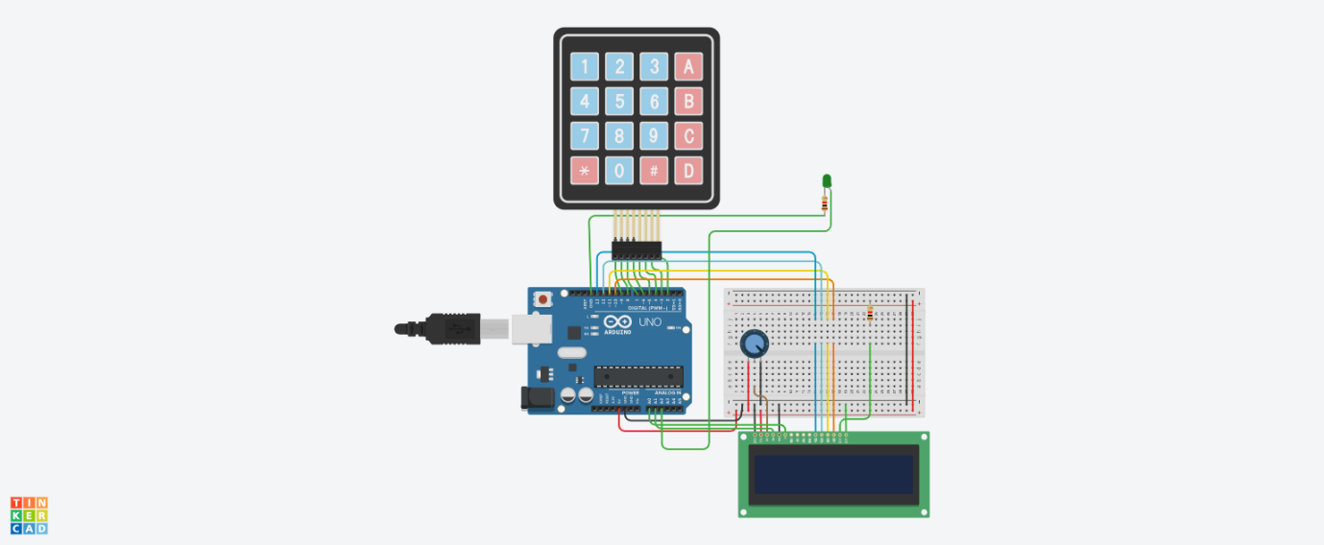
The Interactive Attendance Management Interface aims to simplify attendance tracking for environments such as schools, workplaces, and events. It provides an intuitive way for users to mark their attendance using a keypad and receive immediate feedback via an LCD display.

Components
- Keypad: A 4x4 matrix keypad for user passcode entry.
- LCD Display: A 16x2 LCD for showing prompts and feedback messages.
- LED Indicator: An LED for signaling the access status (granted or denied).
- User Structure: A defined structure to store user information, including the user's name and passcode.

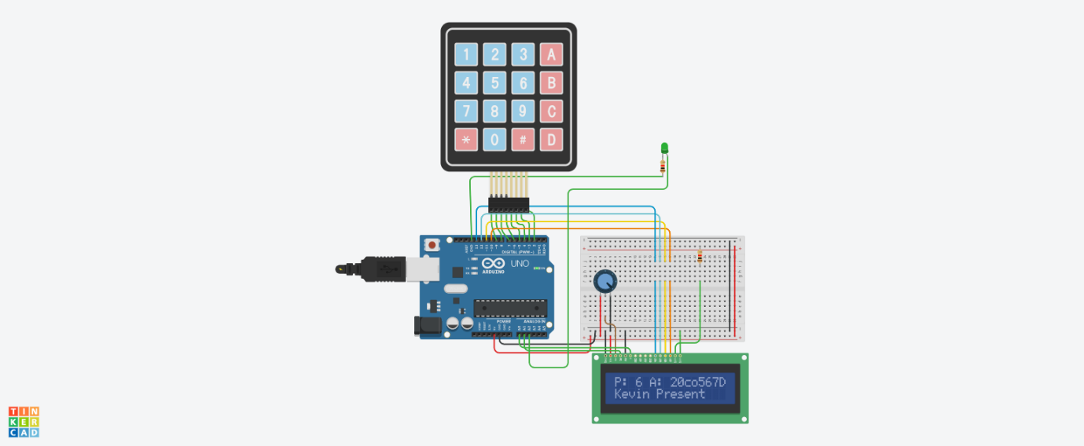

CIRCUIT CONNECTIONS

1. 4x4 Keypad to Arduino
- The keypad has 8 pins, corresponding to 4 rows and 4 columns.
- Here’s how to connect each pin of the keypad to the Arduino:
  - Row 1 (topmost row) to Arduino Pin 9
  - Row 2 to Arduino Pin 8
  - Row 3 to Arduino Pin 7
  - Row 4 to Arduino Pin 6
  - Column 1 (leftmost column) to Arduino Pin 5
  - Column 2 to Arduino Pin 4
  - Column 3 to Arduino Pin 3
  - Column 4 to Arduino Pin 2

2. 16x2 LCD Display to Arduino
- The LCD has 16 pins. Connect them as follows:
  - VSS (Pin 1) to GND on the Arduino.
  - VDD (Pin 2) to 5V on the Arduino.
  - V0 (Pin 3) to the middle pin of a 10K Potentiometer. Connect the other two pins of the potentiometer to 5V and GND. This controls the LCD contrast.
  - RS (Pin 4) to Arduino Pin 15
  - RW (Pin 5) to GND on the Arduino.
  - EN (Pin 6) to Arduino Pin 14
  - D4 (Pin 11) to Arduino Pin 13
  - D5 (Pin 12) to Arduino Pin 12
  - D6 (Pin 13) to Arduino Pin 11
  - D7 (Pin 14) to Arduino Pin 10
  - A (Pin 15) to 5V (for LCD backlight)
  - K (Pin 16) to GND (for LCD backlight)

3. LED (Feedback Light)
- Connect a 220Ω resistor to the cathode (short leg) of the LED and connect it to GND on the breadboard.
- Connect the anode (long leg) of the LED to Arduino Pin 16. This LED will light up as feedback when the passcode is correct.

4. Power and Ground Connections
- Connect the 5V pin on the Arduino to the positive rail on the breadboard.
- Connect GND on the Arduino to the ground rail on the breadboard.
- Ensure all other GND connections (LCD, keypad, LED, and potentiometer) are connected to the ground rail.
- Make sure all VCC (5V) connections (LCD and potentiometer) are connected to the positive rail.

ALGORITHM

- Initialization:
  - The setup() function initializes the LCD and the LED, displaying a prompt for the user to enter their passcode.
- Main Loop Logic:
  - The loop() function continually checks for user input from the keypad.
  - Input handling includes:
    - Clearing the passcode if * is pressed.
    - Appending characters to the v_passcode string until a maximum length of 4 is reached.
    - Validating the passcode when # is pressed.
- Validation Process:
  - The entered passcode is compared against stored passcodes in the user database.
  - If a match is found, the user is marked as present, and the counts are updated.
  - If the passcode is invalid, the LED blinks as feedback.

- Display Updates:
  - The LCD is cleared and updated to prompt the user again after a passcode is validated or after a timeout.
  - The system shows the current length of the entered passcode, total present, and absent counts.
- Timeout Handling:
  - If no input is detected for 5 seconds, the current passcode input is cleared.

CODE

#include <Keypad.h>
#include <LiquidCrystal.h>

const byte ROWS = 4;
const byte COLS = 4;
LiquidCrystal lcd(15, 14, 13, 12, 11, 10);
int led = 16; // Single LED for feedback

char hexaKeys[ROWS][COLS] = {
{'1', '2', '3', 'A'},
{'4', '5', '6', 'B'},
{'7', '8', '9', 'C'},
{'*', '0', '#', 'D'}
};

byte rowPins[ROWS] = {9, 8, 7, 6};
byte colPins[COLS] = {5, 4, 3, 2};
Keypad customKeypad = Keypad(makeKeymap(hexaKeys), rowPins, colPins, ROWS, COLS);
String v_passcode = ""; // Current input passcode
unsigned long lastInputTime = millis();
const unsigned long timeoutDuration = 5000; // 5 seconds timeout
// User structure
struct User {
String name;
String passcode;
};

// User database
User users[] = {
{"Alice", "123A"},
{"Bob", "456B"},
{"Charlie", "789C"},
{"David", "234A"},
{"Eva", "567B"},
{"Frank", "890C"},
{"Grace", "345D"},
{"Hannah", "678A"},
{"Ian", "901B"},
{"Julia", "234C"},
{"Kevin", "567D"},
{"Liam", "890A"},
{"Mia", "123B"},
{"Noah", "456C"},
{"Olivia", "789D"},
{"Parker", "012A"},
{"Quinn", "345B"},
{"Ryan", "678C"},
{"Sophia", "901D"},
{"Tess", "234B"},
{"Uma", "567C"},
{"Vera", "890D"},
{"Will", "123C"},
{"Xena", "456D"},
{"Yara", "789A"},
{"Zara", "012B"}
};

const int userCount = sizeof(users) / sizeof(users[0]);

// Attendance tracking variables
int presentCount = 0;
int absentCount = userCount; // Initially, everyone is absent

void setup() {
lcd.begin(16, 2);
pinMode(led, OUTPUT);
lcd.print("Enter Passcode:");
}

void loop() {
char key = customKeypad.getKey();
if (key) {
lastInputTime = millis(); // Reset the timer

if (key == '*') {
v_passcode = "";
lcd.setCursor(12, 0);
lcd.print(" "); // Clear display
lcd.setCursor(0, 1);
lcd.print("Passcode Cleared ");
delay(1000); // Pause to show the message
lcd.setCursor(0, 1);
lcd.print(" "); // Clear the message
} else if (v_passcode.length() < 4) {
v_passcode += key;
lcd.setCursor(12, 0);
lcd.print(v_passcode);
}

// Check if the user confirms their entry
if (key == '#') {
bool accessGranted = false;
String userName = "";

for (int i = 0; i < userCount; i++) {
if (v_passcode == users[i].passcode) {
userName = users[i].name;
accessGranted = true;
break;
}
}

if (accessGranted) {
lcd.setCursor(0, 1);
lcd.print(userName + " Present");
digitalWrite(led, HIGH); // Turn on LED for valid entry
presentCount++; // Increment present count
absentCount = userCount - presentCount; // Update absent count
delay(2000); // Keep the LED on while displaying "Present"
digitalWrite(led, LOW); // Turn off LED after delay
} else {
lcd.setCursor(0, 1);
lcd.print("Invalid ID ");
for (int i = 0; i < 3; i++) { // Blink LED for invalid entry
digitalWrite(led, HIGH);
delay(200);
digitalWrite(led, LOW);
delay(200);
}
}

// Reset passcode after confirmation
v_passcode = "";
delay(2000); // Delay to show result

// Clear the LCD screen and show the prompt again
lcd.clear();
lcd.print("Enter Passcode:");

// Display total present and absent counts
lcd.setCursor(0, 0);
lcd.print("P: ");
lcd.print(presentCount);
lcd.print(" A: ");
lcd.print(absentCount);
}

// Display current input length
lcd.setCursor(0, 1);
lcd.print("Length: ");
lcd.print(v_passcode.length());
}

// Check for timeout
if (millis() - lastInputTime > timeoutDuration) {
v_passcode = "";
lcd.setCursor(12, 0);
lcd.print(" "); // Clear display
}
}

CODE STRUCTURE

Here's a high-level overview of the code structure:
- Library Inclusion:
  - Include libraries for keypad and LCD management.
- Constants and Variables:
  - Define constants for rows, columns, LED pin, and timeout duration.
  - Initialize variables for user input, last input time, and user database.
- Setup Function:
  - Initialize the LCD and set the LED pin mode.
- Loop Function:
  - Handle keypresses, manage passcode input, verify passcodes, and handle timeouts.

UTILIZATION OF PROGRAMMING CONCEPTS

- Data Structures:
  - Structs: Used for organizing user data (name and passcode) in a clear and manageable way.
  - Arrays: An array of User structs holds all user information, enabling easy access and iteration.
- Control Structures:
  - Conditional Statements: Used to handle different key presses and determine outcomes (e.g., granting access or signaling an error).
  - Loops: A for loop to iterate through the user list for validation.
- String Manipulation:
  - The String class is used to build and manipulate the current passcode as users enter it.
- Timing Functions:
  - The millis() function helps manage the input timeout, ensuring user input is cleared after a period of inactivity.

- User Feedback:
  - Real-time feedback is provided through the LCD and LED, enhancing user experience.

CONCLUSION

In conclusion, the Arduino-based interactive attendance management system provides a secure, efficient, and user-friendly way to control access and track attendance. By using a keypad and LCD for passcode input and feedback, along with timeout and LED indicators, this project effectively enhances security and simplifies attendance logging. It is a flexible and scalable solution suitable for various environments and can serve as a base for further upgrades,such as remote access features.

REFERENCES

  - Programming Arduino: Getting Started with Sketches
  - Electronics hub
  - GeeksforGeeks Embedded C
  - TutorialsPoint Embedded Systems

